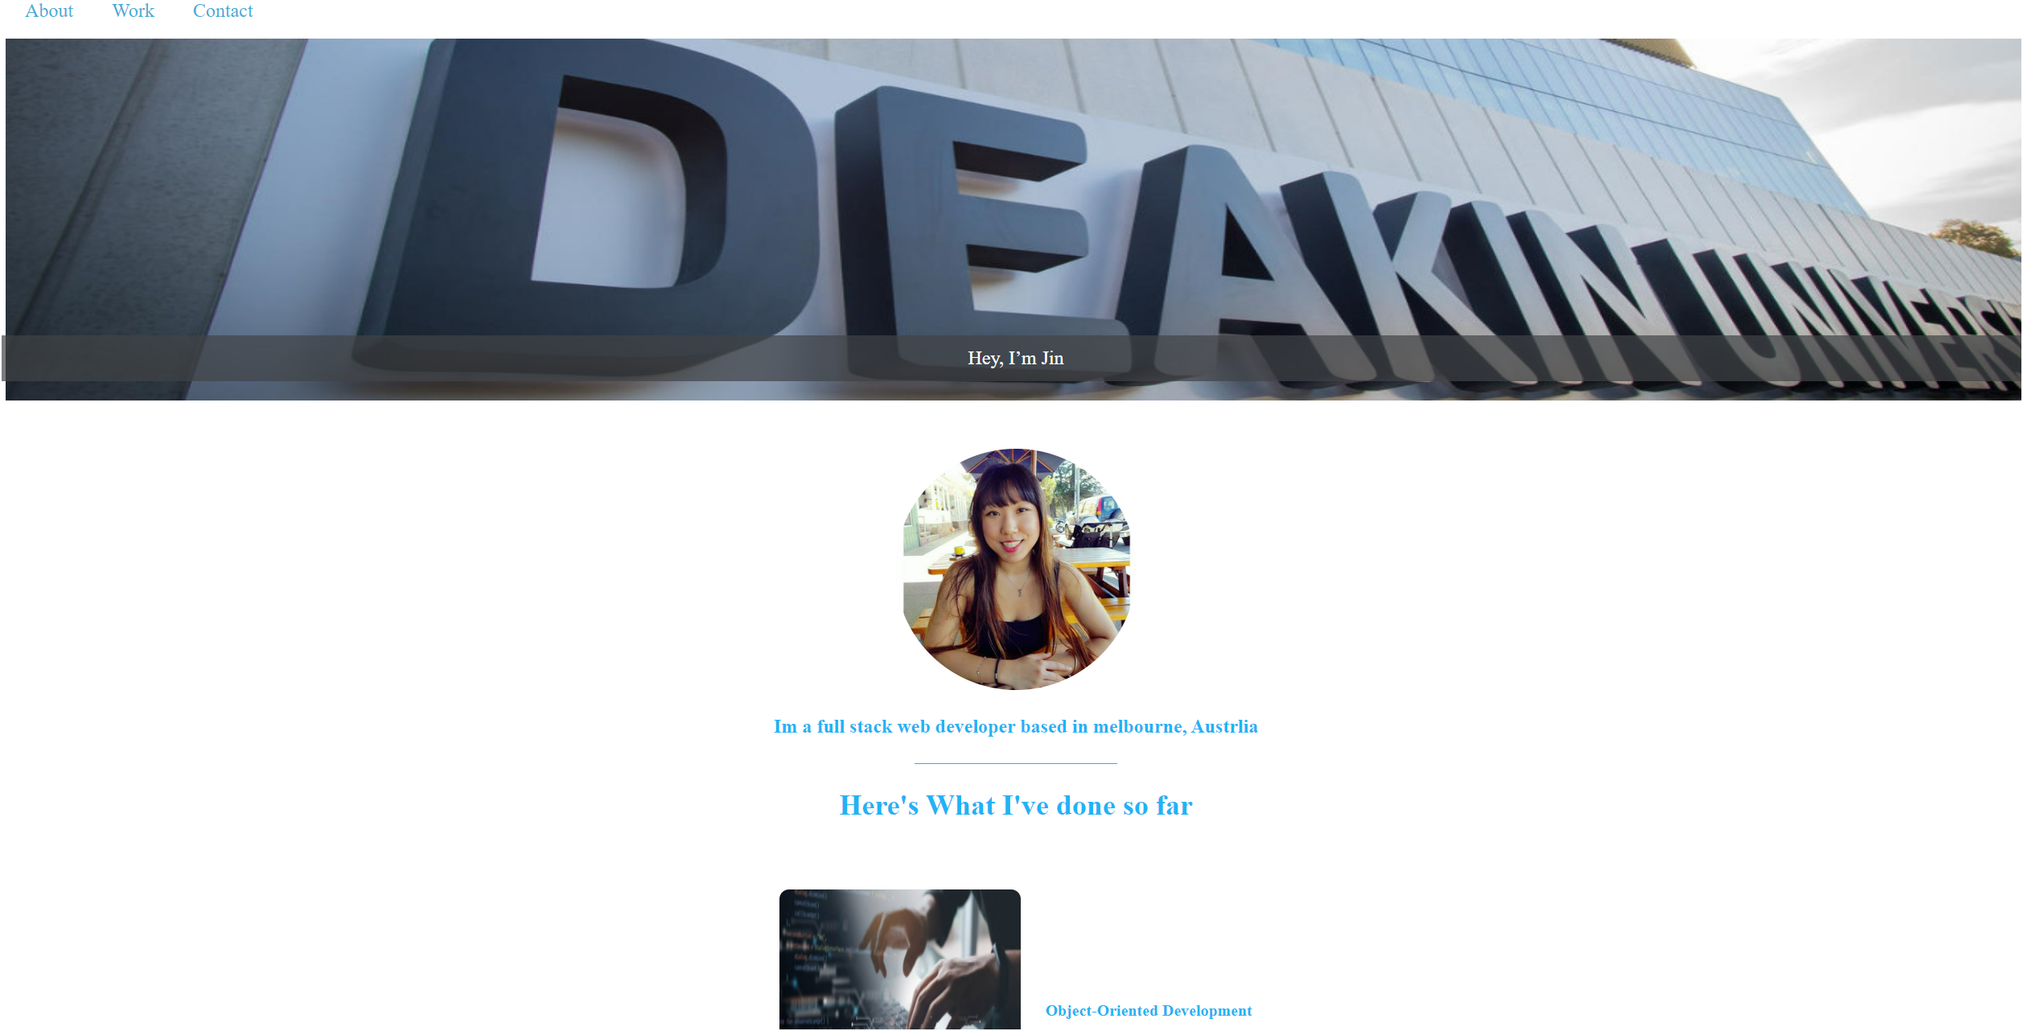

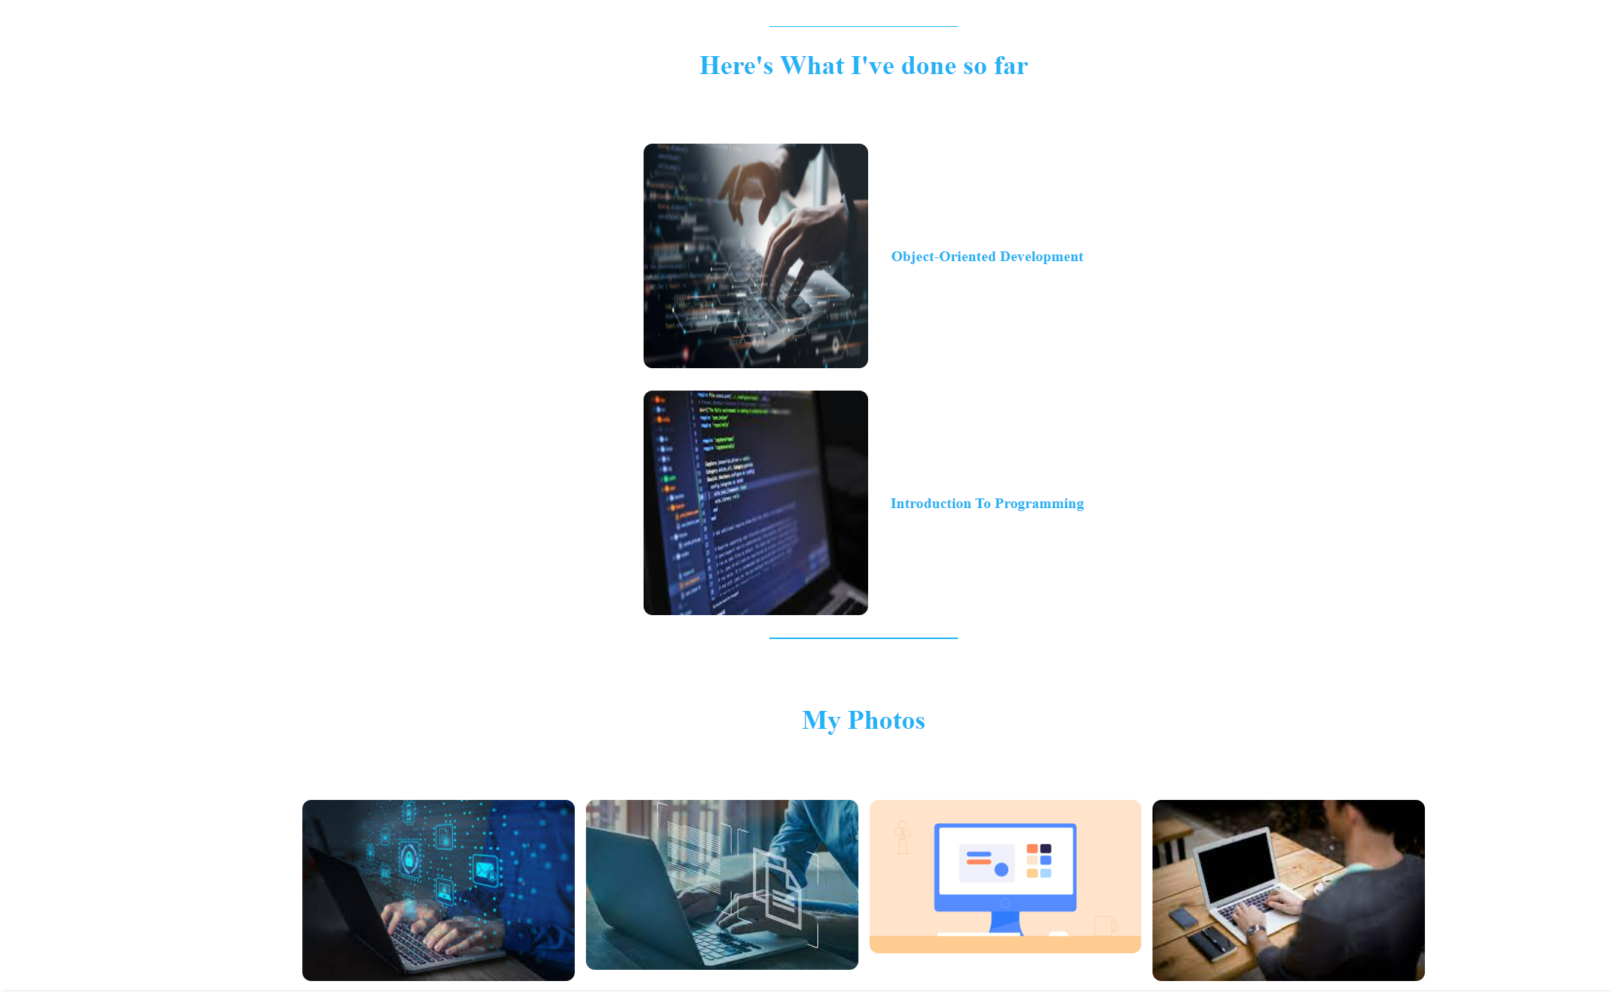

Github:

<https://github.com/jinyorjin/Task1.1.git>

Video:

https://deakin.au.panopto.com/Panopto/Pages/Viewer.aspx?id=a0e27b37-0e9c-413c-a5cd-b1ae00a42ee6